Analysis workflow

1. Process raw data with FreezeFrame.  
   General considerations:   
   The bout duration is set to 0.5s with every step. (This should be reviewed at some point and set to 1s.)   
   - All data needs to be pasted in the “PTSD_project/!analysis/all_cohorts_freezing_FINAL” google spreadsheet.   
   - “date” and “time” fields can be copied from the “Freeze_log.xls” file which comes with all recording sessions.  
   - Freezing threshold needs to be set for each animal individually.  
   1. SEFLA processing: open FreezFrame and load the SEFLA trials. Set up the freezing threshold then set up a data export with custom intervals. The intervals can be found in “sefla_shock_sequence” google sheet but i pasted them here for clarity:   
      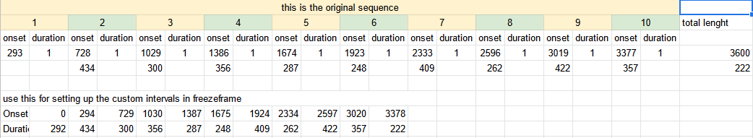
   2. SEFLB processing: open the session in FreezeFrame set up freezing threshold (could be difficult bc these sessions are short) and export the data as per the table below   
      
   3. Processing Recall sessions: open the session in FreezeFrame and load the recall file. Set up the freezing threshold then export the data as per the table blow:  
      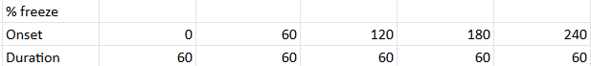
   4. Open the “PTSD_project/!analysis/id_dob” google spreadsheet and add the mice to it. For mice that were ordered from outside sources use the ordering details to determine the approximate DOBs.
2. Processing raw data with google colab notebooks.  
   Open “PTSD_project/!analysis/colab notebooks/nonELS analysis/PTSD_analysis_01” and run the cells. Make sure you save the merged data with the current date during the process.